Meet and Greet Welcome packages  How would you like to start your Cabo vacation with being greeted by some delicious beef and chicken tacos as well as fresh guacamole and chips? Of course, what vacation to Mexico wouldn’t start with a couple of fresh margaritas or cold beers which are both included in our welcome meet and greet package.  Note* We can also customize our welcome packages to suit your needs, we can add or change out any item or beverage if requested  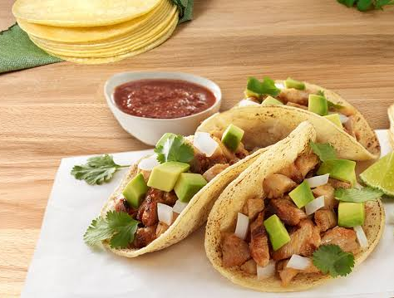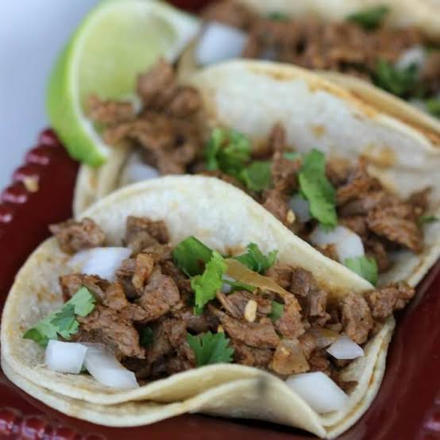 |  | If you would like to be greeted by our FRIENDLY HOSTESS on your arrival with delicious TACOS, guacamole & chips  PLUS, delicious margaritas and cold beers just let us KNOW.  the price is $35 US per person WITH TAXES INCLUDED. CHILDREN under 12 are $18 dollars per person and we will provide bottled water and soft drinks Instead of alcohol  (GRATUITIES are not INCLUDED) THIS service is payable only in cash  Minimum charge $100 US  [Agregue más información relevante aquí]

